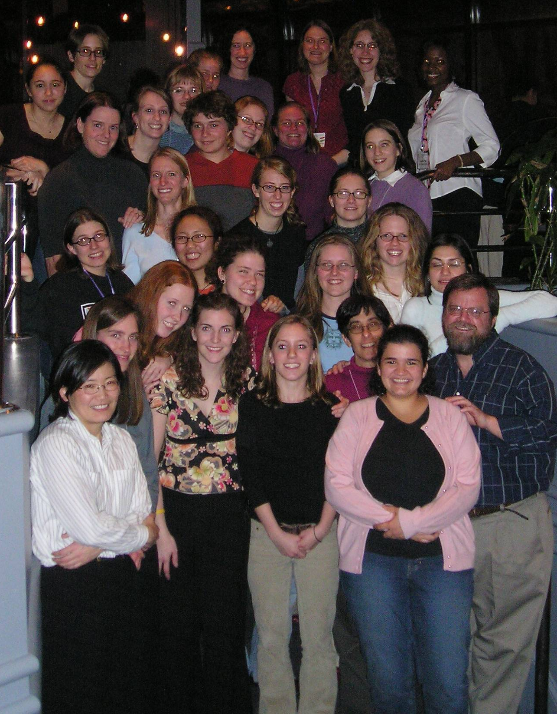

Celebrating its tenth program this year, the Carleton Summer Mathematics Program for Women gathered together former participants for dinner in Atlanta. Pictured above are former SMP students (in alphabetical order): Jackie Kohles Anderson (grad student U Wisconsin), Abra Brisbin (5th year intern Carleton), Teena Conklin Carroll (grad student Georgia Tech), Alissa Crans (Assistant Professor Loyola Marymount U), Angela Desai (grad student U Maryland), Anna Dragonova (grad student UCLA), Rachel Fonstad (undergrad Winona State U), Andrea Frazier (grad student U Iowa), Jen Froelich (grad student U Iowa), Leslie Goemaat (undergrad Carleton), Laura Gunn (Assistant Professor Georgia Southern U), Christina Harlow (undergrad UNC Asheville), Emilie Hogan (undergrad U Wisconsin), Aja Johnson (undergrad Elon U), Jennifer Robin Marshall (undergrad UNC Asheville), Anna Beckhorn Mummert (grad student Penn State), Lena Nguyen (undergrad Cal Tech), Layla Oesper (undergrad Pomona), Carolyn Otto (undergrad U Wisconsin Eau Claire), Laurel Paget-Seekins (landscaper), Pam Richardson (grad student U Virginia), Liz Stanhope (Assistant Professor Willamette U), Calandra Tate (grad student U Maryland), Sarah Tekansik (undergrad Mesa State College), Annalies Vuong (undergrad UC Santa Barbara); and SMP faculty and directors: Laura Chihara (Carleton), Katherine Crowley (St. Olaf), Erica Flapan (Pomona), Tina Garrett (Carleton), Deanna Haunsperger (Carleton), and Steve Kennedy (Carleton).

